**Class 6, Project work**

*Dear students, stay safe and hydrated this summer.*

**1.** Draw on chart paper “Computer and it’s parts” and demonstrate in your classroom.

**2.** List the different hardware on chart paper available in your computer lab then divide them into different categories [**Input device, output device, processing device, memory & storage device**] and demonstrate in your classroom.

**3.** Write all full-form from your book [at last] on chart paper and demonstrate in your classroom.

**[Note: Do any one of them from your own easiness]**

***[We’ll present the best chart out there in our classroom – Class 6]***

**Class 7, Project work**

*Dear students, stay safe and hydrated this summer.*

**1.** Draw on char paper “Working System of Computer” and demonstrate in your classroom.

**2.** Draw on a chart paper the generation of computer, time periods, major component and two features.

**3.** Write all full-form from your book [at last] on chart paper and demonstrate in your classroom.

**[Note: Do any one of them from your own easiness]**

***[We’ll present the best chart out there in our classroom – Class 7]***

**Class 8, Project work**

*Dear students, stay safe and hydrated this summer.*

**1.** Draw on char paper “**Working System of Computer**” and demonstrate in your classroom.

**2.** Draw on a chart paper the generation of computer, time periods, major component and two features.

**3.** Write all full-form from your book [at last] on chart paper and demonstrate in your classroom.

**[Note: Do any one of them from your own easiness]**

***[We’ll present the best chart out there in our classroom – Class 8]***

***Presenting is another part, it’ll hamper your practical marks if you didn’t complete your project work.***

**Class 9, Project work**

*Dear students, stay safe and hydrated this summer.*

**1.** Draw an organizational chart on chart paper types of computers on the basis of work, and explain each of them in points

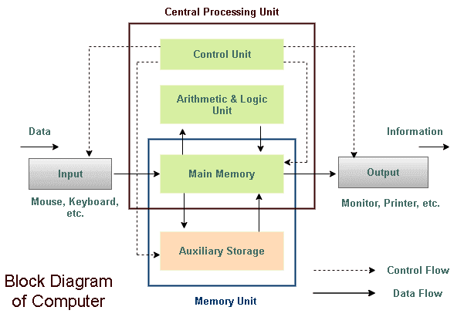**2.** Prepare block diagram of computer system on chart paper.

**3.** Write all full-form from your book [at last] on chart paper and demonstrate in your classroom.

**[Note: Do any one of them from your own easiness]**

***[We’ll present the best chart out there in our classroom – Class 9]***

***Presenting is another part, it’ll hamper your practical marks if you didn’t complete your project work.***

**Class 10, Project work**

*Dear students, stay safe and hydrated this summer.*

**1.** In chart paper draw all topologies of LAN and explain them in points.

**2.** Prepare a PowerPoint Presentation file on the topic “**Current trends of the Internet and its use in Nepal**”

***Use Microsoft 365 to make presentation and send link to me.***

**3.** Write all full-form from your book [at last] on chart paper and demonstrate in your classroom.

***[We’ll present the best chart out there in our classroom – Class 10]***

***Presenting is another part, it’ll hamper your practical marks if you didn’t complete your project work.***

**Class 9, Project work**

*Dear students, stay safe and hydrated this summer.*

**1.** Collect the different information about the different generation of computers and prepare a slide show. [Mail id: [nineclassoo9@gmail.com](mailto:nineclassoo9@gmail.com), and cc to: [bishal.r@gsps.edu.np](mailto:bishal.r@gsps.edu.np)]

**2.** Prepare block diagram of computer system on chart paper.

**3.** Write all full-form from your book [at last] on chart paper and demonstrate in your classroom.

4. Create a personal blog if you’ve not created yet using suitable tools e.g. medium, blogspot, or GitHub or similar. [Mail id: [nineclassoo9@gmail.com](mailto:nineclassoo9@gmail.com), and cc to: [bishal.r@gsps.edu.np](mailto:bishal.r@gsps.edu.np)]

**[Note: Do any one of them from your own easiness]**

***[We’ll present the best chart out there in our classroom – Class 9]***

***Presenting is another part, it’ll hamper your practical marks if you didn’t complete your project work.***